Name Quang Huynh

**Inquiry Lab Form (Cellular Respiration)**

*Problem:* Which exercises change your breathing and heartrate the most due to the process of Cellular Respiration?

*Background: Describe the process of Cellular Respiration (include the materials needed and the products generated in this chemical reaction)*

*Independent Variable*: (Types of exercises compared to being at rest)

**Jumping Jacks and Sprints (exercises)**

*Dependent Variable: (what changed after completing the exercise?)*

Heartrate

*Constants:*(what needs to remain the same to keep your experiment fair?)

1. time 6. height

2. number of jumping jacks 7. same route when sprinting

3. distance of sprints 8. staying in one place when doing jumping jacks

4. tiredness 9. speed

5. weight 10. the same exercise

*Hypothesis: (which exercise do you think will have the greatest impact on your breathing and heartrate?)*

**If we sprint, then the heartrate would increase.**

*Data: (make a data table to record your results and observations, remember to include both heartrate and breathing rate for each type of exercise compared to your resting rate.)*

|  |  |  |  |
| --- | --- | --- | --- |
|  | Table 1 | Table 2 | Table 3 |
| Jumping Jacks | *51 bpm* | *83 bpm* | *91 bpm* |
| *Sprints* | *60 bpm* | *91 bpm* | *105 bpm* |

**Resting Rate = 45 bpm**

**Graph:** (Make a bar graph of your results)

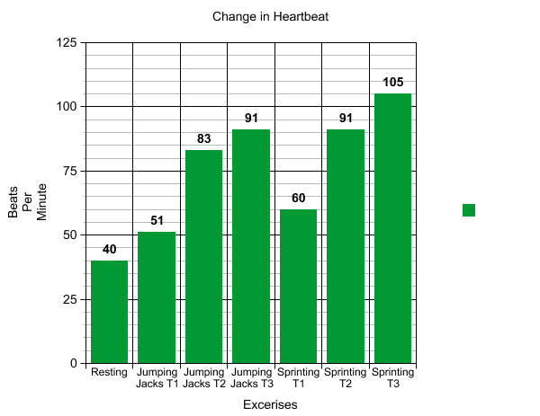

**Explanation / Conclusions:**

Claim:

Sprinting would increase your heartrate more than the jumping jacks.

Evidence:

When I first did the jumping jacks, the beats per minute was 51, and then when I first did the sprints, the heartrate was 60 bpm. Same with the other tables, the sprints had around 7-13 more beats per minute in each table.

Reasoning:

I think the reason why sprints increases in heartrate more than the jumping jacks is because your body is moving more faster.